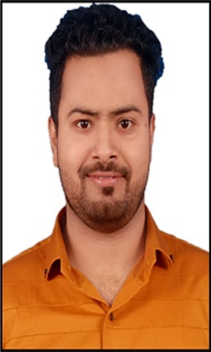

Position Applied for: |  |  |  |  | Java Professional
PERSONAL DATA
Name:  MOHAMMAD |  |  |  |  |  |  |  |  |  |  |  |  |  |  |  |  | JAVED
 |  | (First) |  |  |  |  |  |  |  |  |  | (Middle) |  |  |  |  |  | (Last)
*** as it appears in any of your ID Proof - Voter ID Card or Passport
Date of Birth: |  |  |  | 25-04-1992 |  |  |  | Gender: |  |  |  |  |  |  |  |  |  |  |  |  |  | Male
Marital Status: |  |  |  | Married |  |  |  | Nationality: |  |  |  |  |  |  |  |  |  |  |  |  |  | India
Present Address |  |  |  |  | TA 301 – B Street Number- 5 Tughlakabad Extension
 |  |  |  |  | South East Delhi
City: |  |  |  |  | New Delhi |  |  |  |  | State: |  |  | Delhi |  | Pin : |  |  |  |  |  | 110019
Telephone : ( ) |  |  |  |  |  |  |  |  |  | Mobile: |  |  | 9717307896 |  | Alternate No.: |  |  |  |  |  | 7982852545
E-Mail: |  |  |  |  | mdjavedmansoori@gmail.com |  |  |  |  |  |  |  |  |  |  |  |  |  |  |  | mdjavedmansoori@gmail.com
Permanent Address |  |  |  |  | TA 301 – B Street Number- 5 Tughlakabad Extension
 |  |  |  |  | South East Delhi
City: |  |  |  |  | New Delhi |  |  |  |  | State: |  |  | Delhi |  | Pin : |  |  |  |  | 110019
Telephone : ( ) |  |  |  |  |  |  |  |  |  | Mobile: |  |  | 9717307896
 |  | EDUCATION DETAILS
Course |  |  | Degree and Specialization |  |  | Institute |  |  | University Name & Address |  |  |  |  | From (dd/mm/yyyy) |  | To (dd/mm/yyyy) |  |  | Completed |  |  |  | Program | Percentage
Std. X |  |  | Math,Science,English,Hindi, SST, SKT |  |  | S B B P Sarvodaya boys Sr secondary school |  |  | CBSE &Tughlakabad Extension Delhi-110019 |  |  |  |  | 2006 |  | 2007 |  |  | Yes |  |  |  |  | 49.60 %
 |  |  |  |  |  |  |  |  |  |  |  |  |  |  |  |  |  |  |  |  |  |  | Full Time
Std. XII |  |  | Math, Economics, English,Accounts,Business Studies |  |  | Govt. Boys S.Sec. Secondary No.2 |  |  | CBSE & Kalkaji Delhi-110019 |  |  |  |  | 2008 |  | 2009 |  |  | Yes |  |  |  |  | 65.80 %
 |  |  |  |  |  |  |  |  |  |  |  |  |  |  |  |  |  |  |  |  |  |  | Full Time
Graduation |  |  | BCA(IT) |  |  | Hamdard Unversity |  |  | Jamia Hamdard Unversity & New Delhi-110062 |  |  |  |  | 2009 |  | 2012 |  |  | Yes |  |  |  |  | 73.75 %
 |  |  |  |  |  |  |  |  |  |  |  |  |  |  |  |  |  |  |  |  |  |  | Full Time
Post Graduation |  |  | MCA( CS) |  |  | Hamdard Unversity |  |  | Jamia Hamdard Unversity & New Delhi-110062 |  |  |  |  | 2013 |  | 2016 |  |  | Yes |  |  |  |  | 74.70 %
 |  |  |  |  |  |  |  |  |  |  |  |  |  |  |  |  |  |  |  |  |  |  | Full Time

EMPLOYMENT DETAILS
Kindly fill out the EXACT Details for your complete employment history. Please indicate any gaps/breaks during your employment with reasons. Please start with your most recent employment.
Tenure  From – To  (mm/yy)  Nov 2016 to Mar 2019 | Organization details |  | Work Details:
Tenure  From – To  (mm/yy)  Nov 2016 to Mar 2019 | Name: | Qualtech Consultants PVT LTD | Designation | Associate |  | Engineering |  | Analyst
Tenure  From – To  (mm/yy)  Nov 2016 to Mar 2019 |  |  | Employee No. E-1364
Tenure  From – To  (mm/yy)  Nov 2016 to Mar 2019 | Address: | B - 76 , Sector - 65 | Last Drawn Salary(p.a.) |  |  | 260000
Tenure  From – To  (mm/yy)  Nov 2016 to Mar 2019 |  | Noida - 201301 (UP) | Reason for Leaving |  |  |  | Professional growth and learning moto
Tenure  From – To  (mm/yy)  Mar 2019 to  May 2020 | Organization details |  | Work Details:
Tenure  From – To  (mm/yy)  Mar 2019 to  May 2020 | Name: | Birla Soft Limited | Designation | Associate |  | Technical |  | Consultants
Tenure  From – To  (mm/yy)  Mar 2019 to  May 2020 |  |  | Employee No. 140513
Tenure  From – To  (mm/yy)  Mar 2019 to  May 2020 | Address: | Tower 3 Assotech Business Cresterra Plot no 22 | Last Drawn Salary(p.a.) |  |  | 527049
Tenure  From – To  (mm/yy)  Mar 2019 to  May 2020 |  | Noida-Greater Noida Expy, Sector 135 | Reason for Leaving |  |  |  | Better role and career prospects
Tenure  From – To  (mm/yy)  Mar 2019 to  May 2020 |  | Noida, Uttar Pradesh
Tenure  From – To  (mm/yy)  Sept 2020 till date | Organization details |  | Work Details:
Tenure  From – To  (mm/yy)  Sept 2020 till date | Name: | Hexaware Technologies Ltd. | Designation | Senior |  | Software |  | Engineer
Tenure  From – To  (mm/yy)  Sept 2020 till date |  |  | Employee No. 53137
Tenure  From – To  (mm/yy)  Sept 2020 till date | Address: | 152, Millennium Business Park, | Last Drawn Salary(p.a.) |  |  | 650000
Tenure  From – To  (mm/yy)  Sept 2020 till date |  | Sector -3 TTC Industrial Area, A Block, | Reason for Leaving |  |  |  | Upgrade my self with technologies and professional growth
Tenure  From – To  (mm/yy)  Sept 2020 till date |  | Mahape, Navi Mumbai - 400710
Tenure  From – To  (mm/yy) | Organization details |  | Work Details:
Tenure  From – To  (mm/yy) | Name: |  | Designation
Tenure  From – To  (mm/yy) |  |  | Employee No.
Tenure  From – To  (mm/yy) | Address: |  | Last Drawn Salary(p.a.)
Tenure  From – To  (mm/yy) |  |  | Reason for Leaving
Tenure  From – To  (mm/yy) | Organization details |  | Work Details:
Tenure  From – To  (mm/yy) | Name: |  | Designation
Tenure  From – To  (mm/yy) |  |  | Employee No.
Tenure  From – To  (mm/yy) | Address: |  | Last Drawn Salary(p.a.)
Tenure  From – To  (mm/yy) |  |  | Reason for Leaving
FAMILY DETAILS
NAME OF FAMILY MEMBERS | Relationship | Occupation
Mohammad Rafique | Father | Tailor
Naseem Begum | Mother | Housewife
Shabnam | Wife | Housewife
Zahida | Sister | Student
Mohammad Arshad | Brother | Student

CERTIFICATION / PROFESSIONAL MEMBERSHIP

Name | Type and status
Java Certification Ducat Noida | Java
Dot Net Jamia hamdard University New Delhi | C # Training

HOBBIES
Playing cricket
Listening music and Dance
Reading book, Explore new things and Interacting with different kinds of people

MEDICAL HISTORY
Self | Mohammad Javed |  |  |  |  | Spouse |  | Shabnam |  |  |  |  |  |  |  |  |  |  | Children
Do You Know anybody in IRIS? No
No
Have you ever participated in any coding competition (or familiar with) – Techgig, Stackoverflow or any other?
No

Events Planned in the next 6 months:
Wedding : |  | Already | Operation/Recovery : |  |  |  |  |  |  |  |  |  |  |  | Not Yet |  |  |  |  |  |  |  | Other : |  |  |  |  |  |  | No
Do you have a Passport |  |  | : |  |  | Yes |  |  |  |  | Valid Till |  |  |  |  |  |  |  |  | : |  |  |  |  | 01-November 2028
(If No, I will apply for a new / renewal of passport within 30 days of the date of offer with IRIS and submit the documentary proof of it).
Have you ever applied for Visa |  |  | : |  |  | No
 |  |  | If Yes, |  |  |  | Visa |  |  |  |  |  | Country |  |  |  |  |  |  |  |  |  |  | When |  |  |  |  | Valid Till
 |  |  |  |  |  |  | Visa |  |  |  |  |  | Country |  |  |  |  |  |  |  |  |  |  | When |  |  |  |  | Valid Till
Are there any Visa Rejections / Pending petition on your Passport : No
 |  |  |  |  |  | If Yes, provide details :
Have you traveled overseas |  |  | : |  | No
 |  |  |  |  | If Yes, |  | Country |  |  |  |  |  |  |  |  | Period (from) |  |  |  |  |  |  |  |  |  |  | (to) |  |  |  | Visa
 |  |  |  |  |  |  | Country |  |  |  |  |  |  |  |  | Period (from) |  |  |  |  |  |  |  |  |  |  | (to) |  |  |  | Visa
Do you have a driving license |  |  | : | Yes (Two Wheeler and Four Wheeler Both )
(If No, I will apply for a new / renewal of Car Driving License within 30 days of the date of offer with IRIS and submit the documentary proof of it).
Own Conveyance |  |  | : | Yes |  |  |  |  |  |  |  |  |  | What
Expected CTC |  |  | : | 1200000
Joining Time Required |  |  | : | 3 month officially (negotiable up to 2 month)

Information Release Authorization
- I certify that the statements made in this application are valid and complete to the best of my knowledge. I understand that false or misleading information may result in termination of employment.
- If upon investigation, any of this information is found to be incomplete or inaccurate, I understand that I will be subject to dismissal at any time during my employment.
- I hereby authorize IRIS and/or any of its subsidiaries or affiliates, and any persons or organization acting on its behalf to verify the information presented on this application form (i.e. my educational, employment, residential details or others as required by IRIS) and to procure an investigation report or consumer report for that purpose.
- I hereby grant authority for the bearer to access or to be provided with full details of my previous record. In addition, please provide any other pertinent information requested by the individual presenting this authority.
- I hereby release from liability all persons or entities requesting or supplying such information.
- I authorize to contact my present and past employer.
- I have read, understand, and by my signature consent to these statements.
- All proprietary and confidential information shared with me by IRIS in verbal, written, electronic or any other physical form during the pre-employment stage will be safeguarded and will not be divulged to any third party.
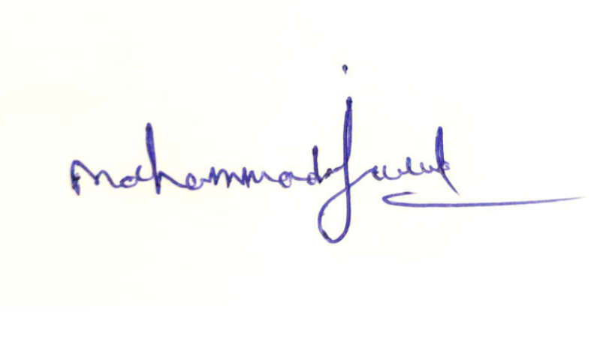  Signature:  Name: Mohammad Javed |  |  |  |  |  |  |  |  |  |  |  |  |  |  |  |  |  |  |  |  | Date: 30-04-2021  Place :New Delhi

